Release Notes

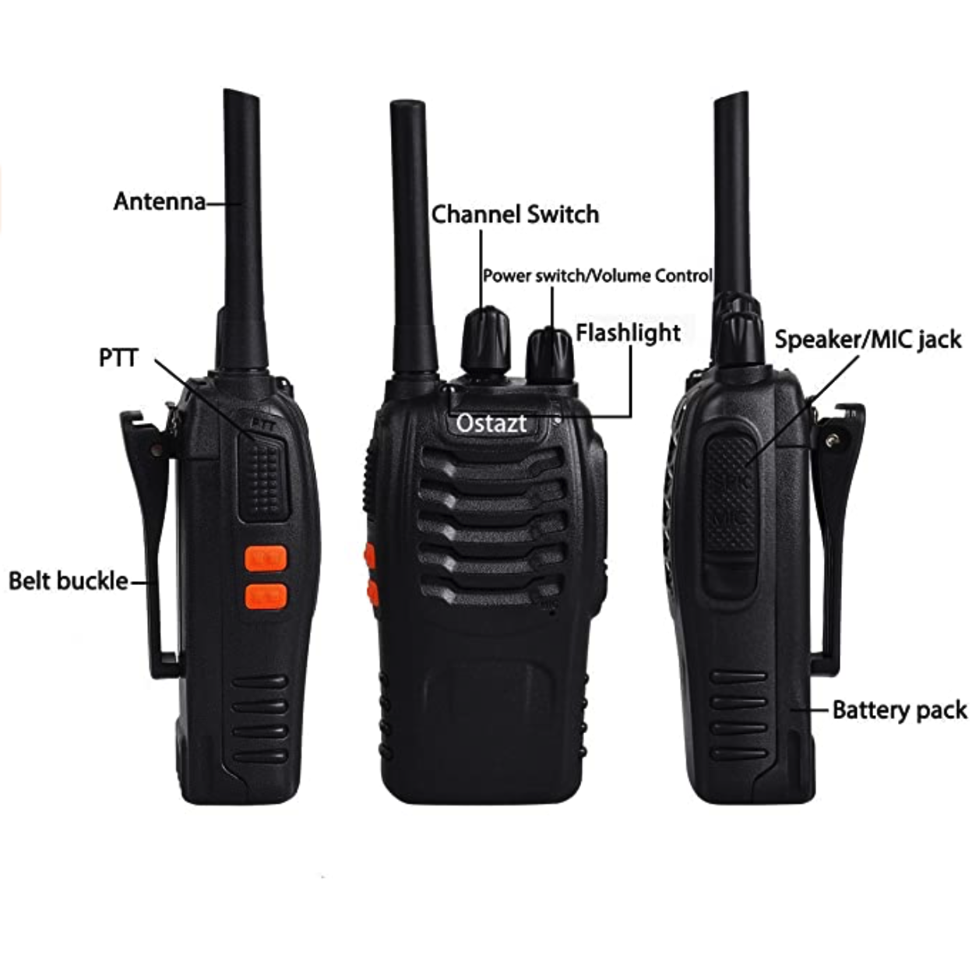

Table of Contents
Version v1.0.0 3
Version v1.1.0 3
Version v1.1.1 4

Version v1.0.0
Version | v1.0.0
Author | Samuel Netherway
Release Date | 16/08/2020
Intended Users | All Users
Changes | Initial release with Licence Free Frequencies on channels 1 through 8.
Compatibility | BF-888  BF-88E
Important Details | UK Licence Free Frequencies List:  - Channel 1: 446.00625  - Channel 2: 446.01875  - Channel 3: 446.03125  - Channel 4: 446.04375  - Channel 5: 446.05625  - Channel 6: 446.06875  - Channel 7: 446.08125  - Channel 8: 446.09375  Only frequencies on channels 1 through 8 are confirmed UK licence free frequencies.

Version v1.1.0
Version | v1.1.0
Author | Samuel Netherway
Release Date | 16/08/2020
Intended Users | All Users
Changes | Removed channel pre-sets 9 through 16.
Compatibility | BF-888  BF-88E
Important Details | UK Licence Free Frequencies List:  - Channel 1: 446.00625  - Channel 2: 446.01875  - Channel 3: 446.03125  - Channel 4: 446.04375  - Channel 5: 446.05625  - Channel 6: 446.06875  - Channel 7: 446.08125  - Channel 8: 446.09375

Version v1.1.1
Version | v1.1.1
Author | Samuel Netherway
Release Date | 16/08/2020
Intended Users | All Users
Changes | Updated channels 1 through 8 to use high power by default.
Compatibility | BF-888  BF-88E
Important Details | UK Licence Free Frequencies List:  - Channel 1: 446.00625  - Channel 2: 446.01875  - Channel 3: 446.03125  - Channel 4: 446.04375  - Channel 5: 446.05625  - Channel 6: 446.06875  - Channel 7: 446.08125  - Channel 8: 446.09375

